Back to School Organizational Checklist ✔ 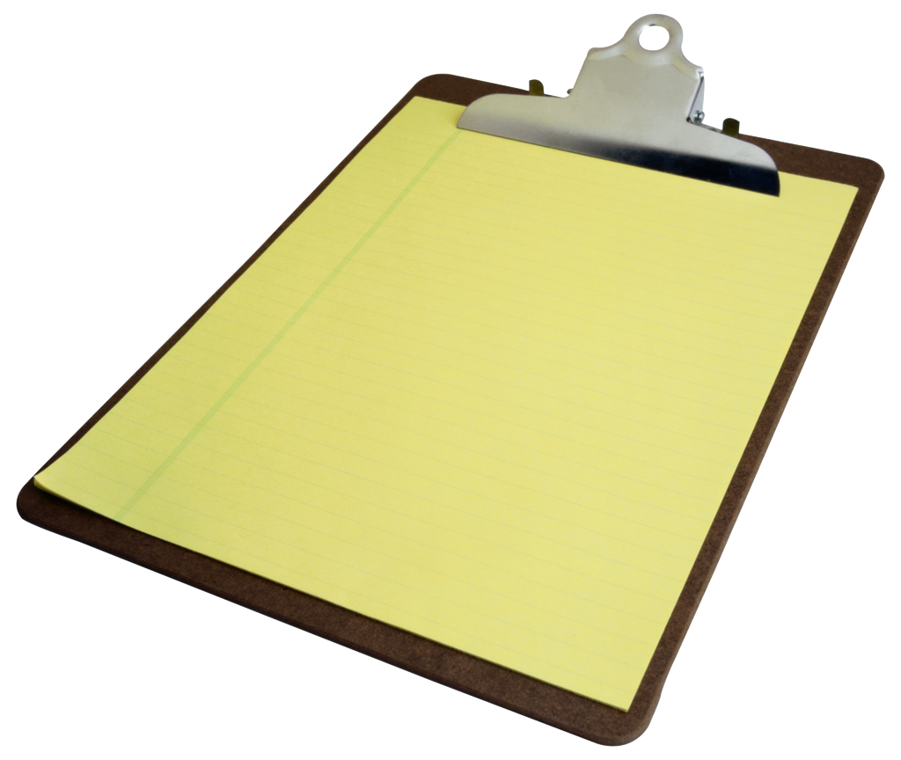

☐ Add numbers of your child’s (or children’s) school(s) to your phone’s address book

☐ Add phone number(s) of bus depot(s) and school bus route numbers to your phone and/or in a prominent spot at home such as near the phone or on the fridge

☐ Update teacher addresses in your email contacts

☐ Bookmark your child (children)’s school website(s) on your computer (and phone, if you have a smart phone)

☐ Upload MCPS calendar to your phone. If your school’s PTA has a calendar to upload with school events, check to see if that has all MCPS dates (early release, holidays, etc.) and just upload that one.

☐ Create a notebook for your child to keep paperwork and school information. Fill out information sheets from the xMinds Back to School Kit to have in one place.

☐ Create an 'IEP Snapshot' that provides a quick overview of the IEP goals. This is especially useful for specials teachers and for students in middle and high school who have multiple teachers daily. (From Chapel Hill Autism Resources and Tools website, http://www.chartnc.com/2013/08/free-back-to-school-printable-iep-at.html)

☐ Prepare a Student Profile to share with school staff that lists your child's strengths and challenges. This is a great tool to paint a well-rounded picture of your child as an individual. Be sure to distribute it to specials teachers, relevant administrators, and possibly even bus drivers. (From Chapel Hill Autism Resources and Tools website, http://www.chartnc.com/2013/07/free-printable-student-profile-2-in.html)

☐ Join the school’s PTA listserv.

☐ Find out if your school has a PTA committee chair for special needs and get contact
information for that person.

☐ Volunteer to be the xMinds Representative in your school. Contact Crystal Poole at
crystal.poole@comcast.net to learn more.

